**BIG DATA LAB-06**

**Creating a employee database:-**

> use employee_soni  
switched to db employee_soni

> db

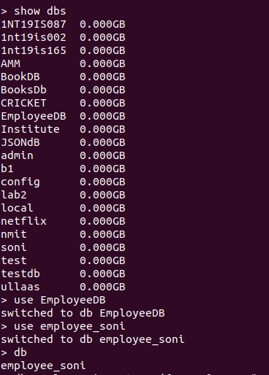

**QUERIES**

1. **Populate the database with atleast 15 documents**

>db.employee.insertOne({Name:{Fname:"Soni",Mname:"A",Lname:""},Age:25,Salary:75000,Designation:"Manager",Role:["Tester","UI designer"]})  
{  
"acknowledged" : true,  
"insertedId" : ObjectId("6295924c40239e527f40e592")  
}  
> db.employee.insertOne({Name:{Fname:"Sonal",Mname:"M",Lname:""},Age:30,Salary:50000,Designation:"Team leader",Role:["Tester","software developer"]})  
{  
"acknowledged" : true,  
"insertedId" : ObjectId("629592ee40239e527f40e593")  
}  
> db.employee.insertOne({Name:{Fname:"Prathap",Mname:"krishna",Lname:"S"},Age:27,Salary:60000,Designation:"Software developer",Role:["Tester","UI designer"]})  
{  
"acknowledged" : true,  
"insertedId" : ObjectId("6295935840239e527f40e594")  
}  
> db.employee.insertOne({Name:{Fname:"sampreeth",Mname:"shetty",Lname:"S"},Age:32,Salary:40000,Designation:"Software developer",Role:["Tester"]})  
{  
"acknowledged" : true,  
"insertedId" : ObjectId("6295939a40239e527f40e595")  
}  
> db.employee.insertOne({Name:{Fname:"Prashanth",Mname:"naidu",Lname:"k"},Age:29,Salary:55000,Designation:"team leader",Role:["software developer","UI designer"]})  
{  
"acknowledged" : true,  
"insertedId" : ObjectId("6295941c40239e527f40e596")  
}  
> db.employee.insertOne({Name:{Fname:"suchitra",Mname:"raj",Lname:"M"},Age:35,Salary:65000,Designation:"UI designer",Role:["tester"]})  
{  
"acknowledged" : true,  
"insertedId" : ObjectId("6295948f40239e527f40e597")  
}  
> db.employee.insertOne({Name:{Fname:"sushmitha",Mname:"P",Lname:"A"},Age:31,Salary:65000,Designation:"Software developer",Role:["UI designer"]})  
{  
"acknowledged" : true,  
"insertedId" : ObjectId("629594db40239e527f40e598")  
}  
> db.employee.insertOne({Name:{Fname:"Varsha",Mname:"H",Lname:""},Age:29,Salary:61000,Designation:"team leader",Role:["UI designer","software developer"]})  
{  
"acknowledged" : true,  
"insertedId" : ObjectId("6295954740239e527f40e599")  
}  
> db.employee.insertOne({Name:{Fname:"Shalini",Mname:"N",Lname:""},Age:35,Salary:45000,Designation:"UI designer",Role:["tester"]})  
{  
"acknowledged" : true,  
"insertedId" : ObjectId("629595ad40239e527f40e59a")  
}  
> db.employee.insertOne({Name:{Fname:"kiran",Mname:"A",Lname:""},Age:27,Salary:71000,Designation:"Manager",Role:["tester","software developer"]})  
{  
"acknowledged" : true,  
"insertedId" : ObjectId("629595f540239e527f40e59b")  
}

> db.employee.insertOne({Name:{Fname:"anand",Mname:"kumar",Lname:"B"},Age:27,Salary:25000,Designation:"scientist",Role:["tester"]})  
{  
"acknowledged" : true,  
"insertedId" : ObjectId("6295972740239e527f40e59c")  
}  
> db.employee.insertOne({Name:{Fname:"rajesh",Mname:"kumar",Lname:"B"},Age:36,Salary:31000,Designation:"scientist",Role:["UI designer"]})  
{  
"acknowledged" : true,  
"insertedId" : ObjectId("6295975c40239e527f40e59d")  
}  
> db.employee.insertOne({Name:{Fname:"bhavani",Mname:"A",Lname:"B"},Age:31,Salary:34000,Designation:"scientist",Role:["tester"]})  
{  
"acknowledged" : true,  
"insertedId" : ObjectId("629597b440239e527f40e59e")  
}  
> db.employee.insertOne({Name:{Fname:"veena",Mname:"A",Lname:"B"},Age:31,Salary:55650,Designation:"engineer",Role:["team leader"]})  
{  
"acknowledged" : true,  
"insertedId" : ObjectId("6295982740239e527f40e59f")  
}  
> db.employee.insertOne({Name:{Fname:"veena",Mname:"p",Lname:""},Age:31,Salary:64300,Designation:"professor",Role:["manager"]})  
{  
"acknowledged" : true,  
"insertedId" : ObjectId("6295985a40239e527f40e5a0")  
}

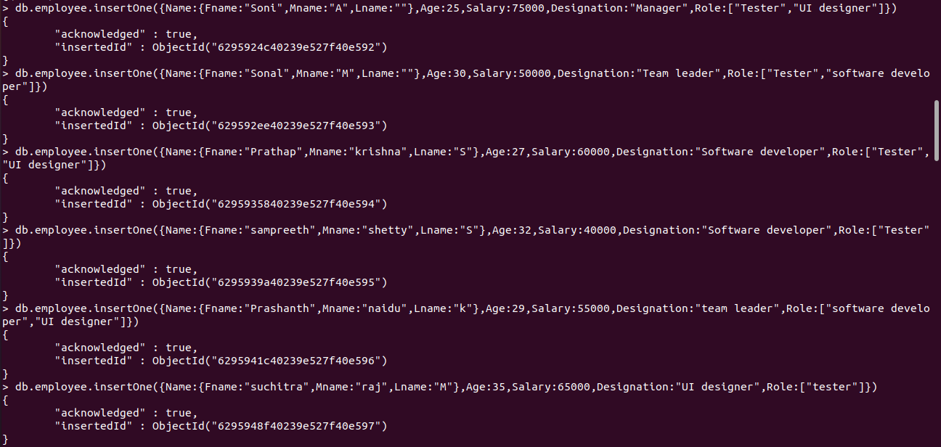

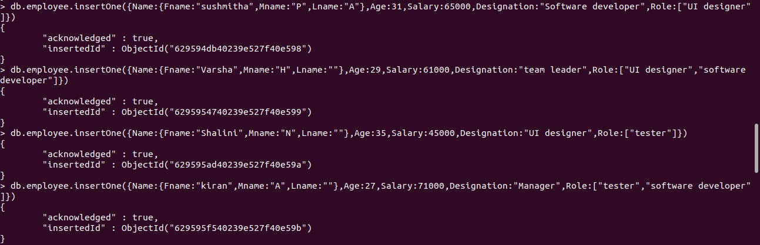

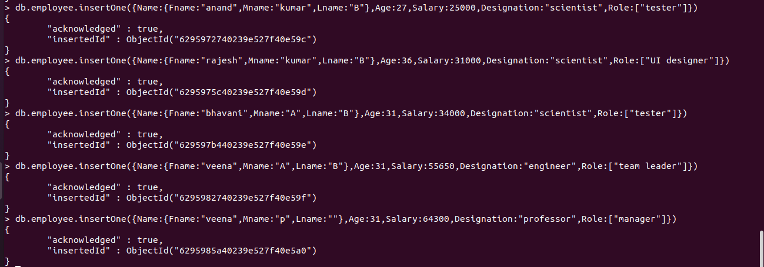

**OUTPUT:-**

> db.employee.find().pretty()  
{  
"_id" : ObjectId("6295924c40239e527f40e592"),  
"Name" : {  
"Fname" : "Soni",  
"Mname" : "A",  
"Lname" : ""  
},  
"Age" : 25,  
"Salary" : 75000,  
"Designation" : "Manager",  
"Role" : [  
"Tester",  
"UI designer"  
]  
}  
{  
"_id" : ObjectId("629592ee40239e527f40e593"),  
"Name" : {  
"Fname" : "Sonal",  
"Mname" : "M",  
"Lname" : ""  
},  
"Age" : 30,  
"Salary" : 50000,  
"Designation" : "Team leader",  
"Role" : [  
"Tester",  
"software developer"  
]  
}  
{  
"_id" : ObjectId("6295935840239e527f40e594"),  
"Name" : {  
"Fname" : "Prathap",  
"Mname" : "krishna",  
"Lname" : "S"  
},  
"Age" : 27,  
"Salary" : 60000,  
"Designation" : "Software developer",  
"Role" : [  
"Tester",  
"UI designer"  
]  
}  
{  
"_id" : ObjectId("6295939a40239e527f40e595"),  
"Name" : {  
"Fname" : "sampreeth",  
"Mname" : "shetty",  
"Lname" : "S"  
},  
"Age" : 32,  
"Salary" : 40000,  
"Designation" : "Software developer",  
"Role" : [  
"Tester"  
]  
}  
{  
"_id" : ObjectId("6295941c40239e527f40e596"),  
"Name" : {  
"Fname" : "Prashanth",  
"Mname" : "naidu",  
"Lname" : "k"  
},  
"Age" : 29,  
"Salary" : 55000,  
"Designation" : "team leader",  
"Role" : [  
"software developer",  
"UI designer"  
]  
}  
{  
"_id" : ObjectId("6295948f40239e527f40e597"),  
"Name" : {  
"Fname" : "suchitra",  
"Mname" : "raj",  
"Lname" : "M"  
},  
"Age" : 35,  
"Salary" : 65000,  
"Designation" : "UI designer",  
"Role" : [  
"tester"  
]  
}  
{  
"_id" : ObjectId("629594db40239e527f40e598"),  
"Name" : {  
"Fname" : "sushmitha",  
"Mname" : "P",  
"Lname" : "A"  
},  
"Age" : 31,  
"Salary" : 65000,  
"Designation" : "Software developer",  
"Role" : [  
"UI designer"  
]  
}  
{  
"_id" : ObjectId("6295954740239e527f40e599"),  
"Name" : {  
"Fname" : "Varsha",  
"Mname" : "H",  
"Lname" : ""  
},  
"Age" : 29,  
"Salary" : 61000,  
"Designation" : "team leader",  
"Role" : [  
"UI designer",  
"software developer"  
]  
}  
{  
"_id" : ObjectId("629595ad40239e527f40e59a"),  
"Name" : {  
"Fname" : "Shalini",  
"Mname" : "N",  
"Lname" : ""  
},  
"Age" : 35,  
"Salary" : 45000,  
"Designation" : "UI designer",  
"Role" : [  
"tester"  
]  
}  
{  
"_id" : ObjectId("629595f540239e527f40e59b"),  
"Name" : {  
"Fname" : "kiran",  
"Mname" : "A",  
"Lname" : ""  
},  
"Age" : 27,  
"Salary" : 71000,  
"Designation" : "Manager",  
"Role" : [  
"tester",  
"software developer"  
]  
}  
{  
"_id" : ObjectId("6295972740239e527f40e59c"),  
"Name" : {  
"Fname" : "anand",  
"Mname" : "kumar",  
"Lname" : "B"  
},  
"Age" : 27,  
"Salary" : 25000,  
"Designation" : "scientist",  
"Role" : [  
"tester"  
]  
}  
{  
"_id" : ObjectId("6295975c40239e527f40e59d"),  
"Name" : {  
"Fname" : "rajesh",  
"Mname" : "kumar",  
"Lname" : "B"  
},  
"Age" : 36,  
"Salary" : 31000,  
"Designation" : "scientist",  
"Role" : [  
"UI designer"  
]  
}  
{  
"_id" : ObjectId("629597b440239e527f40e59e"),  
"Name" : {  
"Fname" : "bhavani",  
"Mname" : "A",  
"Lname" : "B"  
},  
"Age" : 31,  
"Salary" : 34000,  
"Designation" : "scientist",  
"Role" : [  
"tester"  
]  
}  
{  
"_id" : ObjectId("6295982740239e527f40e59f"),  
"Name" : {  
"Fname" : "veena",  
"Mname" : "A",  
"Lname" : "B"  
},  
"Age" : 31,  
"Salary" : 55650,  
"Designation" : "engineer",  
"Role" : [  
"team leader"  
]  
}  
{  
"_id" : ObjectId("6295985a40239e527f40e5a0"),  
"Name" : {  
"Fname" : "veena",  
"Mname" : "p",  
"Lname" : ""  
},  
"Age" : 31,  
"Salary" : 64300,  
"Designation" : "professor",  
"Role" : [  
"manager"  
]  
}

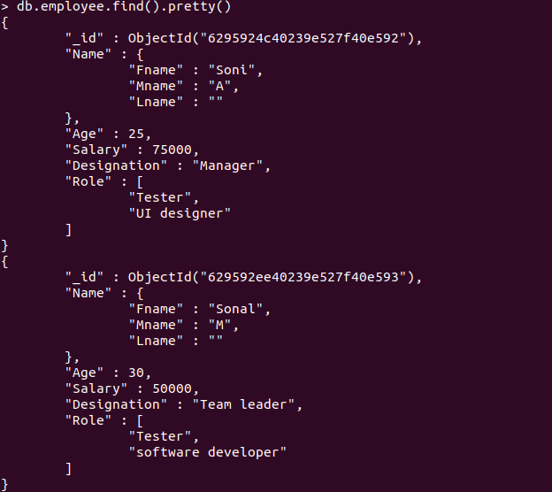

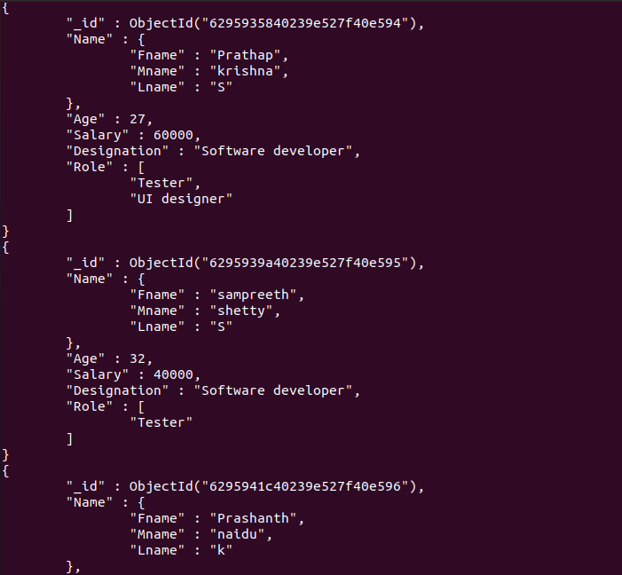

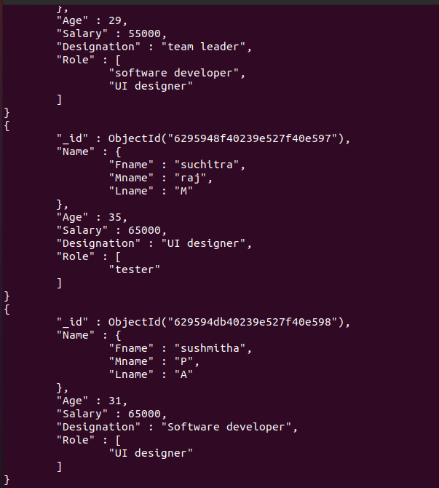

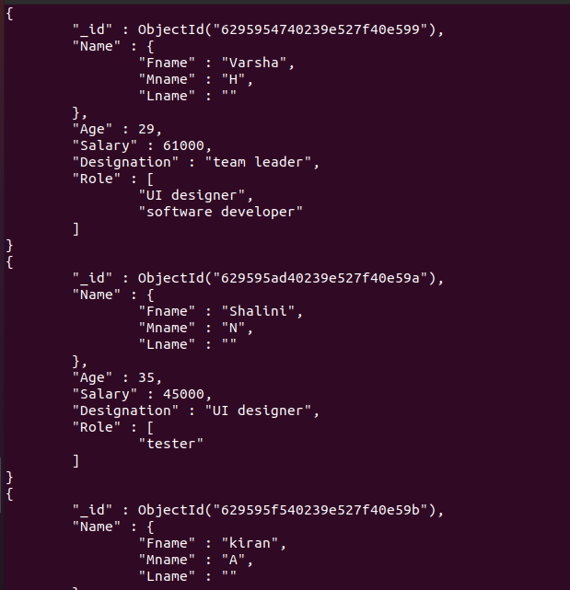

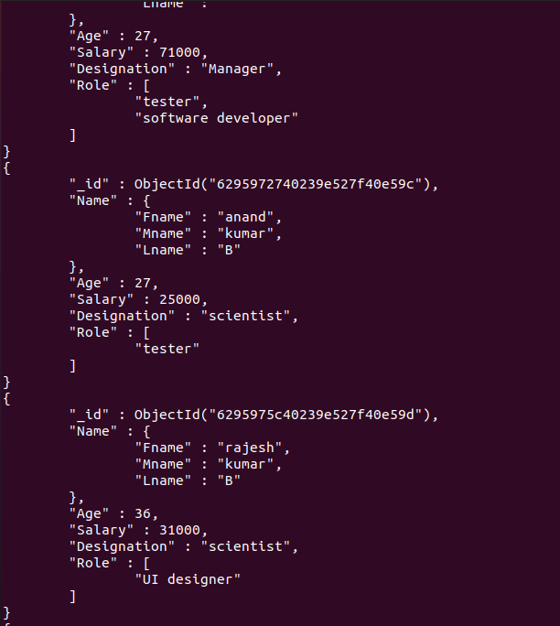

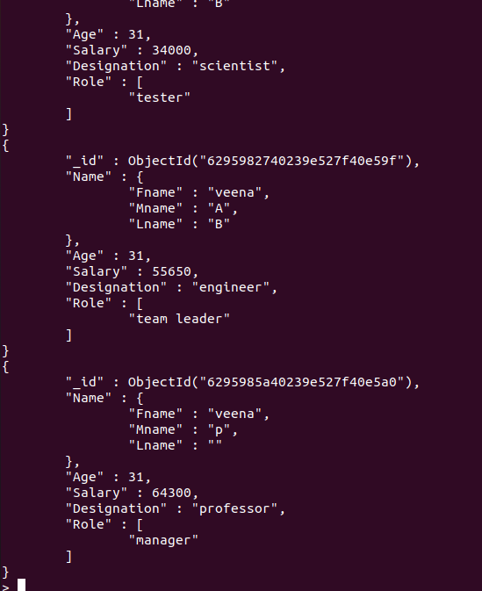

**2. List all the records having salary in the range of 20000- 35000**

> db.employee.find({Salary:{$gt:20000,$lt:35000}})  
{ "_id" : ObjectId("6295972740239e527f40e59c"), "Name" : { "Fname" : "anand", "Mname" : "kumar", "Lname" : "B" }, "Age" : 27, "Salary" : 25000, "Designation" : "scientist", "Role" : [ "tester" ] }  
{ "_id" : ObjectId("6295975c40239e527f40e59d"), "Name" : { "Fname" : "rajesh", "Mname" : "kumar", "Lname" : "B" }, "Age" : 36, "Salary" : 31000, "Designation" : "scientist", "Role" : [ "UI designer" ] }  
{ "_id" : ObjectId("629597b440239e527f40e59e"), "Name" : { "Fname" : "bhavani", "Mname" : "A", "Lname" : "B" }, "Age" : 31, "Salary" : 34000, "Designation" : "scientist", "Role" : [ "tester" ] }

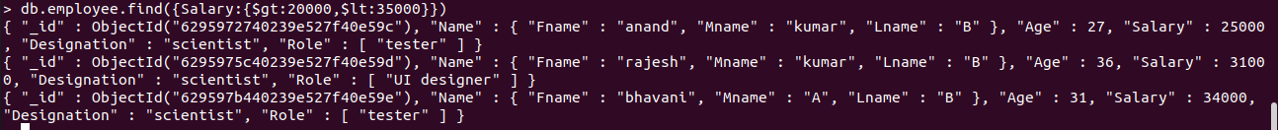

**3.List all the Employee whose Middle name is "Kumar"**

> db.employee.find({"Name.Mname":"kumar"})  
{ "_id" : ObjectId("6295972740239e527f40e59c"), "Name" : { "Fname" : "anand", "Mname" : "kumar", "Lname" : "B" }, "Age" : 27, "Salary" : 25000, "Designation" : "scientist", "Role" : [ "tester" ] }



**4.Count the number of Employees who has a role "Manager" in the Role field**

> db.employee.find({"Role":"manager"}).count()  
1

**C:\Users\Bhavani A\Desktop\aq4.png**

**5.Find out all the documents who have age < 35 and salary in the range of 30000-35000**

> db.employee.find({Salary:{$gt:30000,$lt:35000},Age:{$lt:35}})  
{ "_id" : ObjectId("629597b440239e527f40e59e"), "Name" : { "Fname" : "bhavani", "Mname" : "A", "Lname" : "B" }, "Age" : 31, "Salary" : 34000, "Designation" : "scientist", "Role" : [ "tester" ] }

**C:\Users\Bhavani A\Desktop\aq5.png**

**6.Delete an Employee whose "Firstname" is "Rajesh" and having the designation as "Scientist"**

> db.employee.deleteOne({"Name.Fname":"rajesh"},{"Designation":"scientist"})  
{ "acknowledged" : true, "deletedCount" : 1 }

**C:\Users\Bhavani A\Desktop\aq6.png**

**7.Update all the Employees whose role is "Team Lead" with a salary of 55650 INR**

> db.employee.updateMany({Role:"team leader"},{$set:{Salary:55650}})  
{ "acknowledged" : true, "matchedCount" : 1, "modifiedCount" : 0 **}**

**C:\Users\Bhavani A\Desktop\aq7.png**

**8.Group all the Employees by their age(common age should be there) and calculate the average salary obtained in the each group**

> db.employee.aggregate([{$group:{_id:"$Age",total:{$avg:"$Salary"}}}])  
{ "_id" : 25, "total" : 75000 }  
{ "_id" : 32, "total" : 40000 }  
{ "_id" : 30, "total" : 50000 }  
{ "_id" : 27, "total" : 52000 }  
{ "_id" : 29, "total" : 58000 }  
{ "_id" : 31, "total" : 54737.5 }  
{ "_id" : 35, "total" : 55000 }

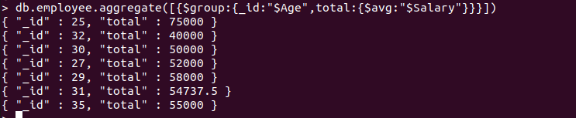

**9.Apply the map-reduce to perform the above operation and obtain the results**

> var mapfunction=function(){emit(this.Age,this.Salary)}  
> var reducefunction=function(key,values){return Array.avg(values)}  
>db.employee.mapReduce(mapfunction,reducefunction,{'out':'result'})  
{ "result" : "result", "ok" : 1 }  
> db.result.find()  
{ "_id" : 25, "value" : 75000 }  
{ "_id" : 32, "value" : 40000 }  
{ "_id" : 30, "value" : 50000 }  
{ "_id" : 27, "value" : 52000 }  
{ "_id" : 29, "value" : 58000 }  
{ "_id" : 31, "value" : 54737.5 }  
{ "_id" : 35, "value" : 55000 }

